**Question 5**

Tables used in queries:

**EMPLOYEE**

**CREATE TABLE** EMPLOYEE  
(  
 **EID INT PRIMARY KEY NOT NULL**,  
 **ENAME VARCHAR**(20) **NOT NULL**,  
 **EMPLOYMENTDATE DATE NOT NULL**)

**CLOTHINGMODEL**

**CREATE TABLE** CLOTHINGMODEL  
(  
 **MODELNAME VARCHAR**(30) **PRIMARY KEY NOT NULL**,  
 **SEX VARCHAR**(1) **NOT NULL**,  
 **AGERANGE VARCHAR**(10),  
 **MODELDISCOUNT INT DEFAULT** 0,  
 **PRICE FLOAT**(53) **NOT NULL**,  
 **CATID INT NOT NULL**,  
 **CONSTRAINT** CLOTHINGMODEL_CLOTHINGCATEGORY_CATID_FK **FOREIGN KEY** (**CATID**) **REFERENCES** CLOTHINGCATEGORY (**CATID**)  
);  
**COMMENT ON COLUMN** CLOTHINGMODEL.**MODELDISCOUNT IS 'Percentage Values'**

**CARTDETAILS**

**CREATE TABLE** CARTDETAILS  
(  
 **CARTID INT NOT NULL**,  
 **COLOR VARCHAR**(15) **NOT NULL**,  
 **SIZE VARCHAR**(10) **NOT NULL**,  
 **MODELNAME VARCHAR**(30) **NOT NULL**,  
 **QUANTITY INT DEFAULT** 1 **NOT NULL**,  
 **CONSTRAINT** CARTDETAILS_CARTID_COLOR_SIZE_MODELNAME_PK **PRIMARY KEY** (**CARTID**, **COLOR**, **SIZE**, **MODELNAME**),  
 **CONSTRAINT** CARTDETAILS_SHOPPINGCART_CARTID_FK **FOREIGN KEY** (**CARTID**) **REFERENCES** SHOPPINGCART (**CARTID**),  
 **CONSTRAINT** CARTDETAILS_CLOTHINGUNIT_COLOR_SIZE_MODELNAME_FK **FOREIGN KEY** (**SIZE**) **REFERENCES** CLOTHINGUNIT (**SIZE**)  
)

**CLOTHINGCATEGORY**

**CREATE TABLE** CLOTHINGCATEGORY  
(  
 **CATID INT PRIMARY KEY NOT NULL**,  
 **CATNAME VARCHAR**(50) **NOT NULL**,  
 **CATTYPE VARCHAR**(20) **NOT NULL**,  
 **CATEGORYDISCOUNT INT DEFAULT** 0 **NOT NULL**);  
**COMMENT ON COLUMN** CLOTHINGCATEGORY.**CATEGORYDISCOUNT IS 'Displayed as percentage'**

**ORDER**

**CREATE TABLE ORDER**(  
 **ORDERID INT PRIMARY KEY NOT NULL**,  
 **ORDERTYPE VARCHAR**(10) **NOT NULL**,  
 **PAYMENTMETHOD VARCHAR**(20) **NOT NULL**,  
 **ORDERDATE DATE DEFAULT CURRENT DATE NOT NULL**,  
 **FINALAMOUNT FLOAT**(53) **NOT NULL**,  
 **CUSTOMEREMAIL VARCHAR**(100) **NOT NULL**,  
 **HANDLEDATE DATE**,  
 **HANDLER INT**,  
 **SHIPPINGID INT**,  
 **BILLINGID INT**,  
 **CARTID INT**,  
 **TRACKINGNUMBER VARCHAR**(13),  
 **CONSTRAINT** ORDER_CUSTOMER_EMAIL_FK **FOREIGN KEY** (**CUSTOMEREMAIL**) **REFERENCES** CUSTOMER (**EMAIL**),  
 **CONSTRAINT** ORDER_EMPLOYEE_EID_FK **FOREIGN KEY** (**HANDLER**) **REFERENCES** EMPLOYEE (**EID**),  
 **CONSTRAINT** ORDER_SHIPPINGADDRESS_SA_ID_FK **FOREIGN KEY** (**SHIPPINGID**) **REFERENCES** SHIPPINGADDRESS (**SA_ID**),  
 **CONSTRAINT** ORDER_BILLINGADDRESS_BA_ID_FK **FOREIGN KEY** (**BILLINGID**) **REFERENCES** BILLINGADDRESS (**BA_ID**),  
 **CONSTRAINT** ORDER_SHOPPINGCART_CARTID_FK **FOREIGN KEY** (**CARTID**) **REFERENCES** SHOPPINGCART (**CARTID**),  
 **CONSTRAINT** ORDER_SHIPPINGINFO_TRACKINGNUMBER_FK **FOREIGN KEY** (**TRACKINGNUMBER**) **REFERENCES** SHIPPINGINFO (**TRACKINGNUMBER**)  
);  
**COMMENT ON COLUMN** ORDER.**ORDERTYPE IS 'PURCHASE or REFUND'**;  
**COMMENT ON COLUMN** ORDER.**PAYMENTMETHOD IS 'VISA/MASTERCARD/AMERICAN EXPRESS/PAYPAL/INTERAC'**;  
**COMMENT ON COLUMN** ORDER.**SHIPPINGID IS 'Shipping Address ID'**;  
**COMMENT ON COLUMN** ORDER.**BILLINGID IS 'Billing Address ID'**;  
**COMMENT ON COLUMN** ORDER.**CARTID IS 'Shopping Cart ID'**

**UNITSTOCKING**

**CREATE TABLE** UNITSTOCKING  
(  
 **MODELNAME VARCHAR**(30) **NOT NULL**,  
 **QUANTITYAVAILABLE INT NOT NULL**,  
 **LOCATION VARCHAR**(20) **NOT NULL**,  
 **COLOR VARCHAR**(15) **NOT NULL**,  
 **SIZE VARCHAR**(10) **NOT NULL**,  
 **CONSTRAINT** UNITSTOCKING_COLOR_SIZE_PK **PRIMARY KEY** (**COLOR**, **MODELNAME**, **SIZE**, **LOCATION**),  
 **CONSTRAINT** UNITSTOCKING_WAREHOUSE_LOCATION_FK **FOREIGN KEY** (**LOCATION**) **REFERENCES** WAREHOUSE (**LOCATION**)  
);  
**COMMENT ON COLUMN** UNITSTOCKING.**QUANTITYAVAILABLE IS 'Current Stock'**

**Queries**

1. Description: This query selects all the employees that have started working from the date 2016-01-01 or later

**SELECT** *\** **FROM** EMPLOYEE **WHERE EMPLOYMENTDATE** >= **DATE '2016-01-01'**;

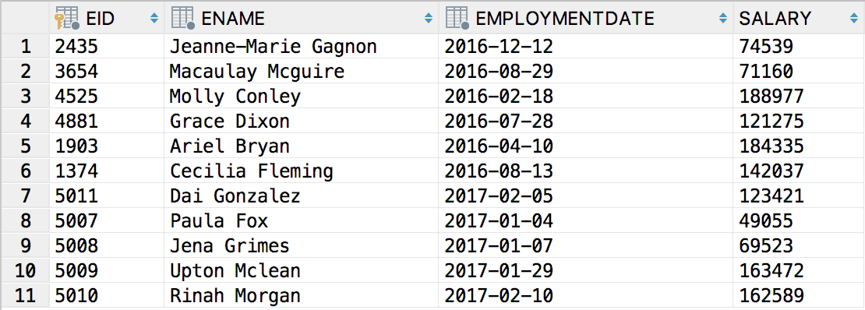

1. Description: This query selects all the items from the carts of id 5000 and 5007, and outputs what items are in each cart. The query is an inner join of order, clothing model, and cart details.

**SELECT** CLOTHINGMODEL.**PRICE**, MYORDERID, MYCARTID, MYORDERTYPE, MYORDERDATE, MYCOLOR, MYMODELNAME, MYSIZE  
 **FROM** CLOTHINGMODEL **INNER JOIN** (  
 **SELECT** ORDER.**ORDERID AS** MYORDERID, ORDER.**CARTID AS** MYCARTID, ORDER.**ORDERTYPE AS** MYORDERTYPE, ORDER.**ORDERDATE AS** MYORDERDATE, CARTDETAILS.**COLOR AS** MYCOLOR, CARTDETAILS.**MODELNAME AS** MYMODELNAME, CARTDETAILS.**SIZE AS** MYSIZE  
 **FROM ORDER INNER JOIN** CARTDETAILS  
 **ON** ORDER.**CARTID** = CARTDETAILS.**CARTID  
 WHERE** (ORDER.**CARTID** = 5000 **OR** ORDER.**CARTID** = 5007))  
 **ON** CLOTHINGMODEL.**MODELNAME** = MYMODELNAME;

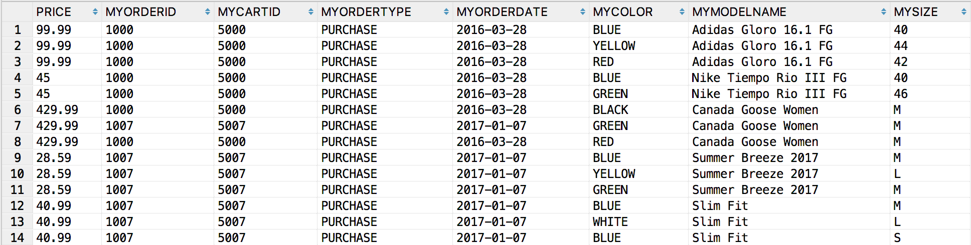

1. Description: This query selects all the category names from clothing category whose catid is not in our subquery. Our subquery selects all clothing categories with ID’s between 1000 and 4000, so our final query will select all clothing categories NOT between 1000 and 4000.

**SELECT** CATNAME **FROM** CLOTHINGCATEGORY **WHERE CATID NOT IN** (**SELECT CATID FROM** CLOTHINGMODEL  
 **WHERE CATID BETWEEN** 1000 **and** 4000);

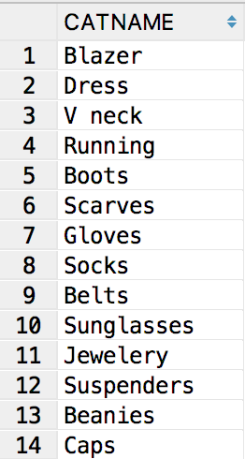

1. Description: This query selects all the refunds that customers made and the average amount per refund

**SELECT** *AVG*(**FINALAMOUNT**) **AS** AVERAGEREFUND, *COUNT*(*\**) **as COUNT  
FROM ORDER WHERE ORDERTYPE** = **'REFUND'**;

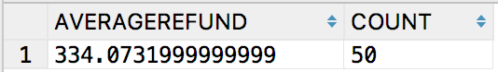

1. Description: With this query, we can see the total stock we have in each warehouse location

**SELECT** *SUM*(QUANTITYAVAILABLE), **LOCATION  
FROM** UNITSTOCKING  
**WHERE** QUANTITYAVAILABLE > 0  
**GROUP BY LOCATION**;

